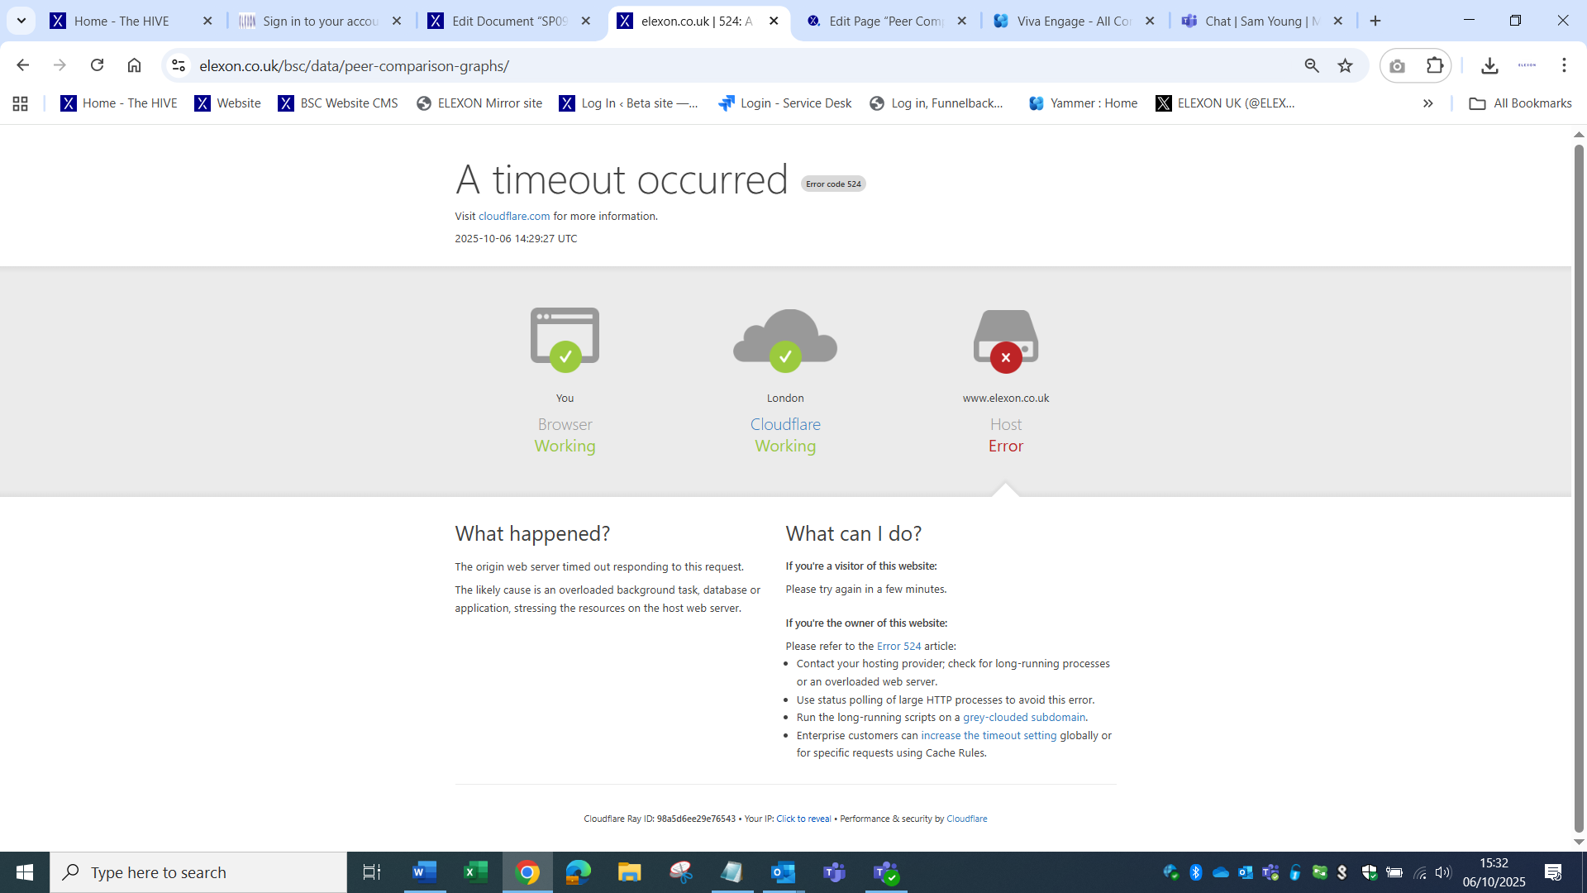

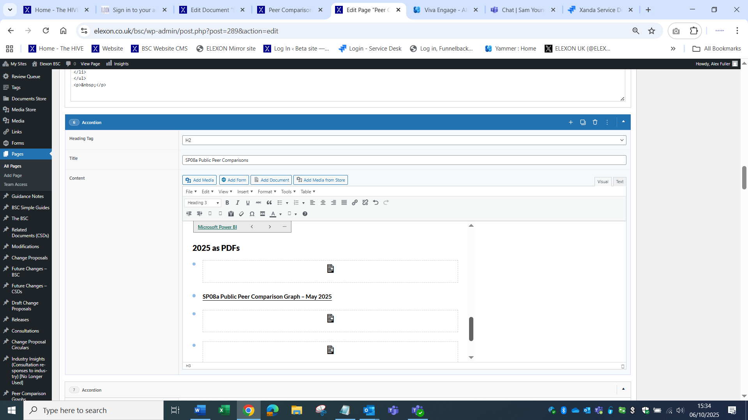

SP08a Public Peer Comparison Graph – July 2025
https://assets.elexon.co.uk/wp-content/uploads/sites/11/2025/10/06151201/PPC-SP08a-July-2025.pdf
<li><a href="https://assets.elexon.co.uk/wp-content/uploads/sites/11/2025/10/06151201/PPC-SP08a-July-2025.pdf">SP08a Public Peer Comparison Graph – July 2025</a></li>

SP08b Public Peer Comparison Graph – July 2025
https://assets.elexon.co.uk/wp-content/uploads/sites/11/2025/10/06151305/PPC-SP08b-July-2025.pdf

SP09 Public Peer Comparison Graph – July 2025

SP08a Public Peer Comparison Graph
<h3>2024 as PDFs</h3>
<ul>
<li>
<p>[documentstore id="215868" label="SP08a Public Peer Comparison Graph – December 2024" filesize="true"]</p>
</li>
<li>
<p>[documentstore id="215390" label="SP08a Public Peer Comparison Graph – November 2024" filesize="true"]</p>
</li>
<li>
<p>[documentstore id="214188" label="SP08a Public Peer Comparison Graph - October 2024" filesize="true"]</p>
</li>
<li>
<p>[documentstore id="213192" label="SP08a Public Peer Comparison Graph - September 2024" filesize="true"]</p>
</li>
<li><a href="https://assets.elexon.co.uk/wp-content/uploads/sites/11/2024/10/16084145/PPC-SP08a-August-2024.pdf" target="_blank" rel="noopener">SP08a Public Peer Comparison Graph - August 2024</a></li>
<li><a href="https://assets.elexon.co.uk/wp-content/uploads/sites/11/2024/09/19090327/PPC-SP08a-July-2024.pdf" target="_blank" rel="noopener">SP08a Public Peer Comparison Graph - July 2024</a></li>
<li><a href="https://assets.elexon.co.uk/wp-content/uploads/sites/11/2024/08/16131856/PPC-SP08a-June-2024.pdf" target="_blank" rel="noopener">SP08a Public Peer Comparison Graph - June 2024</a></li>
<li><a href="https://assets.elexon.co.uk/wp-content/uploads/sites/11/2024/08/16131433/PPC-SP08a-May-2024.pdf" target="_blank" rel="noopener">SP08a Public Peer Comparison Graph - May 2024</a></li>
<li><a href="https://assets.elexon.co.uk/wp-content/uploads/sites/11/2024/06/19085555/PPC-SP08a-April-2024.pdf" target="_blank" rel="noopener">SP08a Public Peer Comparison Graph - April 2024</a></li>
<li><a href="https://assets.elexon.co.uk/wp-content/uploads/sites/11/2024/05/15145201/PPC-SP08a-March-2024.pdf">SP08a Public Peer Comparison Graph - March 2024</a></li>
<li><a href="https://assets.elexon.co.uk/wp-content/uploads/sites/11/2024/04/17144130/PPC-SP08a-February-2024.pdf">SP08a Public Peer Comparison Graph - February 2024</a></li>
<li><a href="https://assets.elexon.co.uk/wp-content/uploads/sites/11/2024/03/15103124/PPC-SP08a-January-2024.pdf">SP08a Public Peer Comparison Graph - January 2024</a></li>
</ul>

SP08b Public Peer Comparisons
<h3>2024 as PDFs</h3>
<ul>
<li>
<p>[documentstore id="215871" filesize="true"]</p>
</li>
<li>
<p>[documentstore id="215392" label="SP08b Public Peer Comparison Graph – November 2024" filesize="true"]</p>
</li>
<li>
<p>[documentstore id="214193" label="SP08b Public Peer Comparison Graph - October 2024" filesize="true"]</p>
</li>
<li>
<p>[documentstore id="213194" label="SP08b Public Peer Comparison Graph - September 2024" filesize="true"]</p>
</li>
<li><a href="https://assets.elexon.co.uk/wp-content/uploads/sites/11/2024/10/16084236/PPC-SP08b-August-2024.pdf">SP08b Public Peer Comparison Graph - August 2024</a></li>
<li><a href="https://assets.elexon.co.uk/wp-content/uploads/sites/11/2024/09/19090506/PPC-SP08b-July-2024.pdf">SP08b Public Peer Comparison Graph - June 2024</a></li>
<li><a href="https://assets.elexon.co.uk/wp-content/uploads/sites/11/2024/08/16131907/PPC-SP08b-June-2024.pdf">SP08b Public Peer Comparison Graph - June 2024</a></li>
<li><a href="https://assets.elexon.co.uk/wp-content/uploads/sites/11/2024/08/16131443/PPC-SP08b-May-2024.pdf">SP08b Public Peer Comparison Graph - May 2024</a></li>
<li><a href="https://assets.elexon.co.uk/wp-content/uploads/sites/11/2024/06/19085714/PPC-SP08b-April-2024.pdf">SP08b Public Peer Comparison Graph - April 2024</a></li>
<li><a href="https://assets.elexon.co.uk/wp-content/uploads/sites/11/2024/05/15145306/PPC-SP08b-March-2024.pdf">SP08b Public Peer Comparison Graph - March 2024</a></li>
<li><a href="https://assets.elexon.co.uk/wp-content/uploads/sites/11/2024/03/15103254/PPC-SP08b-January-2024.pdf">SP08b Public Peer Comparison Graph - February 2024</a></li>
<li><a href="https://assets.elexon.co.uk/wp-content/uploads/sites/11/2024/03/15103254/PPC-SP08b-January-2024.pdf">SP08b Public Peer Comparison Graph - January 2024</a></li>
</ul>

SP09 Public Peer Comparison Graph – July 2025
<h3>2024 as PDFs</h3>
<ul>
<li>
<p>[documentstore id="215873"]</p>
</li>
<li>
<p>[documentstore id="215394" label="SP09 Public Peer Comparison Graph – November 2024" filesize="true"]</p>
</li>
<li>
<p>[documentstore id="214195" label="SP09 Public Peer Comparison Graph - October 2024" filesize="true"]</p>
</li>
<li>
<p>[documentstore id="213196" label="SP09 Public Peer Comparison Graph - September 2024" filesize="true"]</p>
</li>
<li><a href="https://assets.elexon.co.uk/wp-content/uploads/sites/11/2024/10/16084323/PPC-SP09-August-2024.pdf">SP09 Public Peer Comparison Graph - August 2024</a></li>
<li><a href="https://assets.elexon.co.uk/wp-content/uploads/sites/11/2024/09/19090607/PPC-SP09-July-2024.pdf">SP09 Public Peer Comparison Graph - July 2024</a></li>
<li><a href="https://assets.elexon.co.uk/wp-content/uploads/sites/11/2024/08/16131917/PPC-SP09-June-2024.pdf">SP09 Public Peer Comparison Graph - June 2024</a></li>
<li><a href="https://assets.elexon.co.uk/wp-content/uploads/sites/11/2024/08/16131454/PPC-SP09-May-2024.pdf">SP09 Public Peer Comparison Graph - May 2024</a></li>
<li><a href="https://assets.elexon.co.uk/wp-content/uploads/sites/11/2024/06/19085821/PPC-SP09-April-2024.pdf">SP09 Public Peer Comparison Graph - April 2024</a></li>
<li><a href="https://assets.elexon.co.uk/wp-content/uploads/sites/11/2024/04/17144346/PPC-SP09-February-2024.pdf">SP09 Public Peer Comparison Graph - March 2024</a></li>
<li><a href="https://assets.elexon.co.uk/wp-content/uploads/sites/11/2024/04/17144346/PPC-SP09-February-2024.pdf">SP09 Public Peer Comparison Graph - February 2024</a></li>
<li><a href="https://assets.elexon.co.uk/wp-content/uploads/sites/11/2024/03/15103351/PPC-SP09-January-2024.pdf">SP09 Public Peer Comparison Graph - January 2024</a></li>
</ul>

